Creating an array :



Common method:

* Access an Array item using the index position



* Loop over an Array

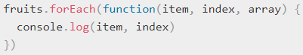

* Add an item to the end of an Array



* Add an item to the beginning of an Array



* Remove an item from the end of an Array



* Remove an item from the beginning of an Array



* Find the index of an item in the Array



* Remove an item by index position



* Remove items from an index position

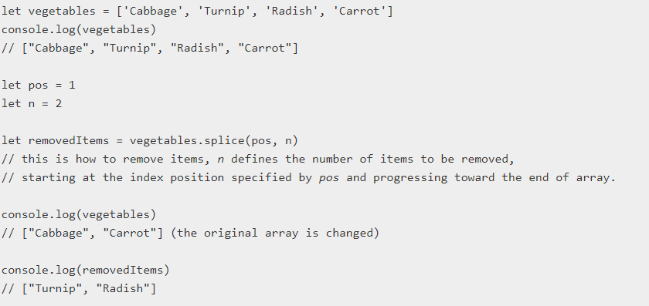

* Copy an Array



**DE-structuring arrays**

It’s basically unpacking the array values into distinct variable, without assigning them one by one.

* Simple example,



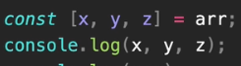 **=> **

* Skipping some values example,





**Output => **

* Rest operator example to get bunch of data, but it has limitations since we can not control what data to get.

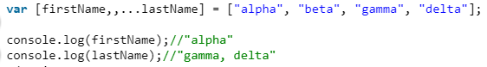

* We can swap values easily without going through a temp variable to store, using the destructuring properties.

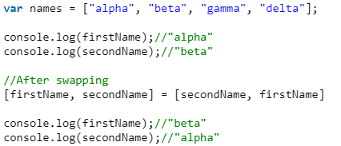

* We can also extract data from a function. Advantage is we can extract the data we need only.

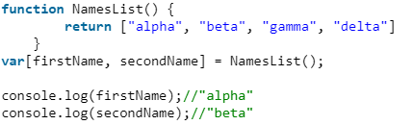

**DE-structuring Objects**

